**SHELL SCRIPT**

**1. Create a script named “myscript” in current directory to do the following.**

**a) display “hello user”**

**b) list files in current directory**

**c) name of logged in user**

**d) date**

**Ans:**

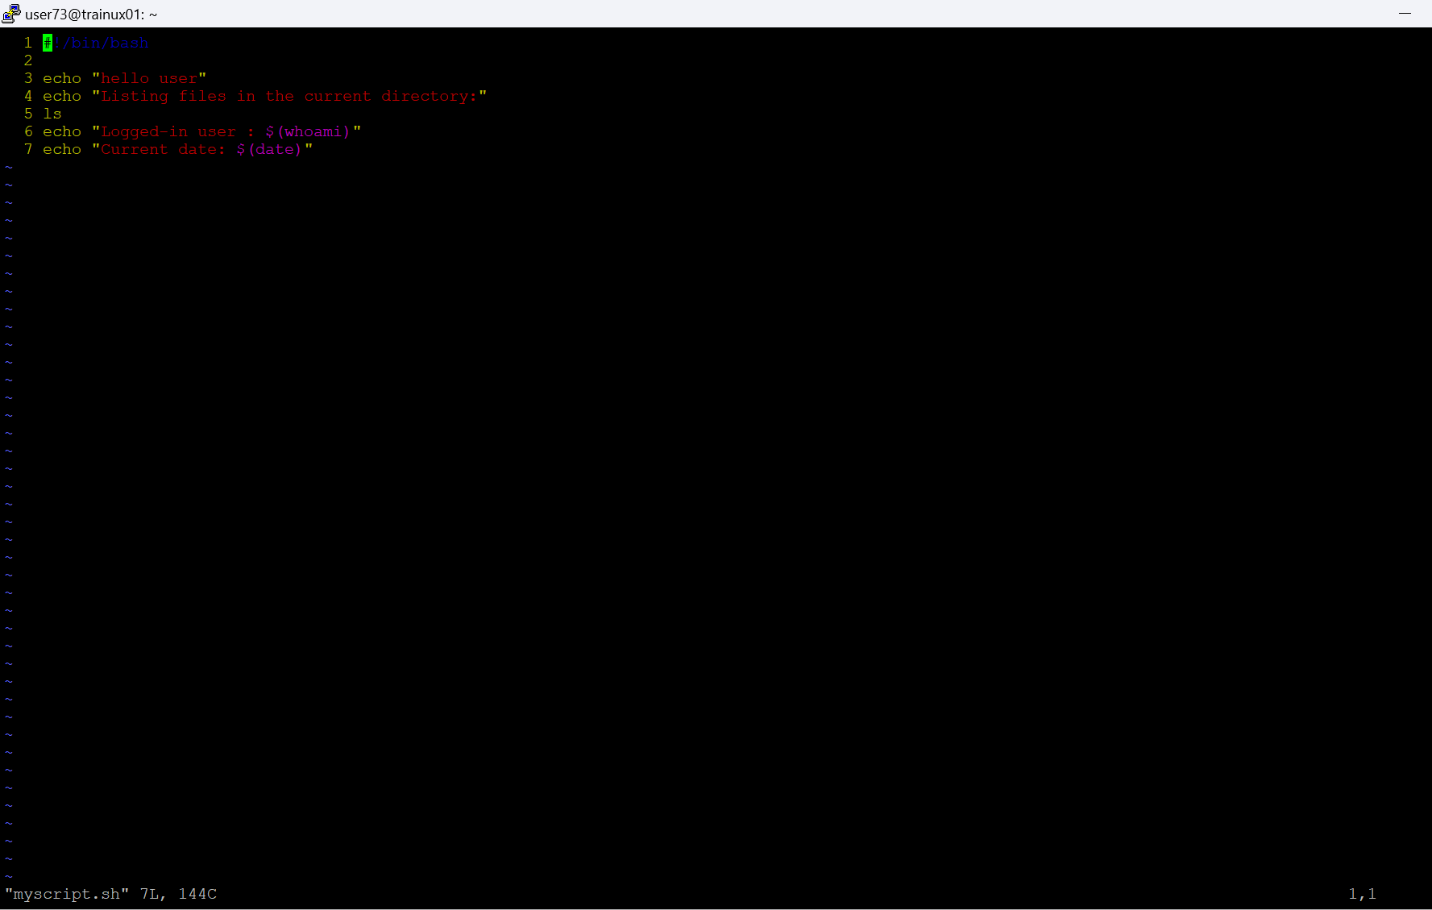

**2. Add execute permission and Run the script from**

**a) current directory**

**3. Create a subdirectory named “test”**

**Ans:**

mkdir test